FILE HANDLING

AIM:

To demonstrate the file handling in c++ using some function.

ALGORITHM:

1: Create, Open and Write to a File
Declare an fstream object.
Open the file in write mode using ios::out.
Check whether the file is created successfully.
Write the given text into the file.
Close the file.

2: Open and Append Text to the File
Declare an fstream object.
Open the existing file in append mode using ios::app.
Check whether the file is opened successfully.
Append additional text at the end of the file.
Close the file.

3: Open and Read Text from the File
Declare an fstream object and a string variable.
Open the file in read mode using ios::in.
Check whether the file is opened successfully.
Read the contents of the file line by line.
Display the file contents on the screen.
Close the file.

4: Print Content After 20th Character
Declare an fstream object and a string variable.
Open the file in read mode using ios::in.
Check whether the file is opened successfully.
Move the file pointer to the 20th character using seekg().
Read the content from the current pointer position.
Display the content after the 20th character.

PROGRAM:

/*
* Program to demostrate file handling in C++
* 1.Create ,open and write text to a file
* Author : MUTHUGANESH S
* Date : 28/1/2026
* Filename: FileHandling1.cpp
* retval : void
*/

#include <iostream>
#include <fstream>
using namespace std;

int main(){
fstream File;
string Text;

File.open("Sample.txt", ios::out); // Open file in write mode
if(!File){
cout << "Error in creating file..." << endl;
return -1;
}

File << "Hello World!"; // Write text to file
File.close(); // Close file
}

OUTPUT:

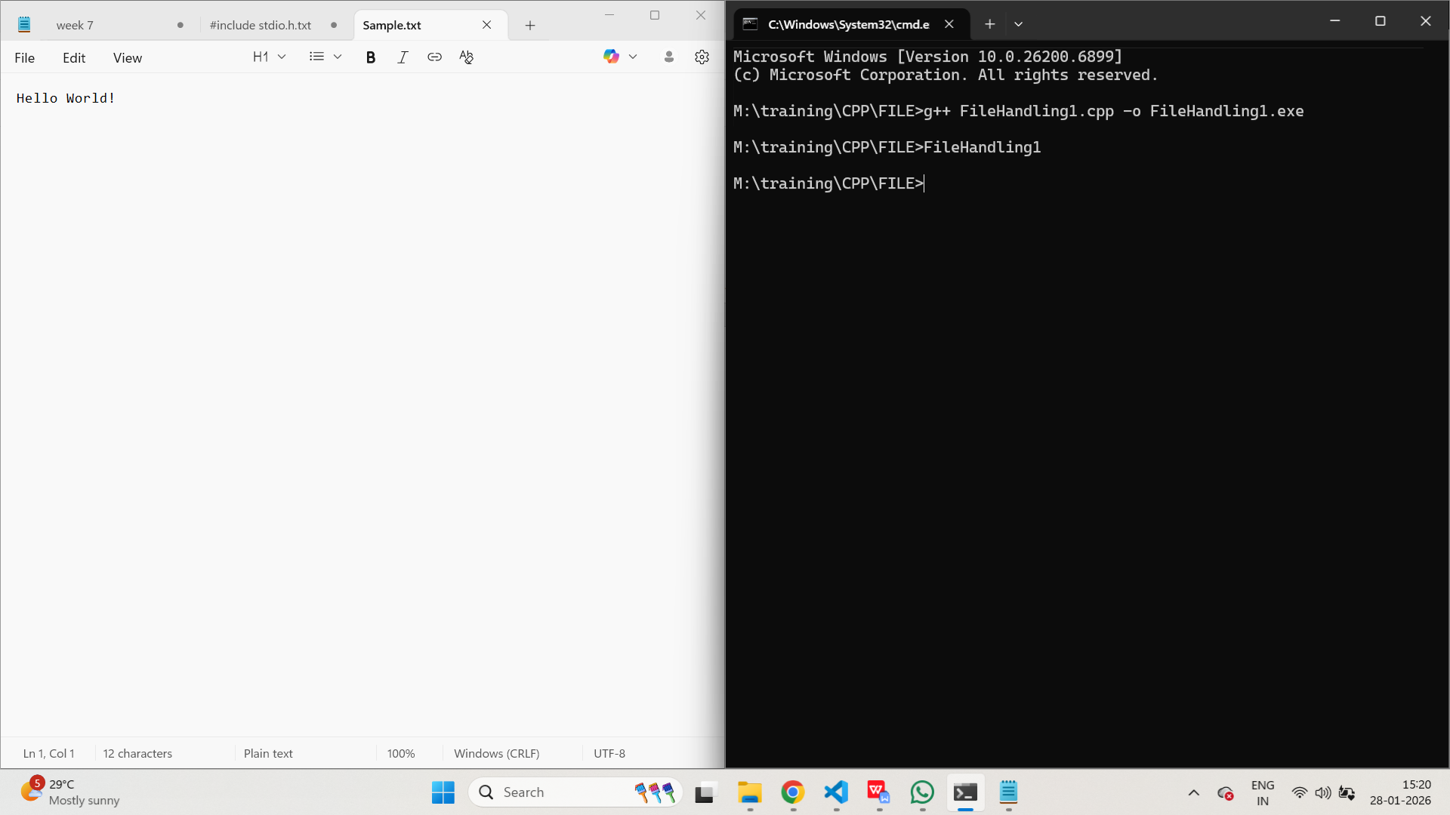

PROGRAM:

/*
* Program to demostrate file handling in C++
* 2. open and append more text to the file
* Author : MUTHUGANESH S
* Date : 28/1/2026
* Filename: FileHandling2.cpp
* retval : void
*/

#include <iostream>
#include <fstream>
using namespace std;

int main(){
fstream File;
string Text;

File.open("Sample.txt", ios::app); // Open file in append mode
if(!File){
cout << "Error in opening file for appending..." << endl;
return -1;
}
File << "\nWelcome to C++."; // Append text to file
File.close(); // Close file
}

OUTPUT:

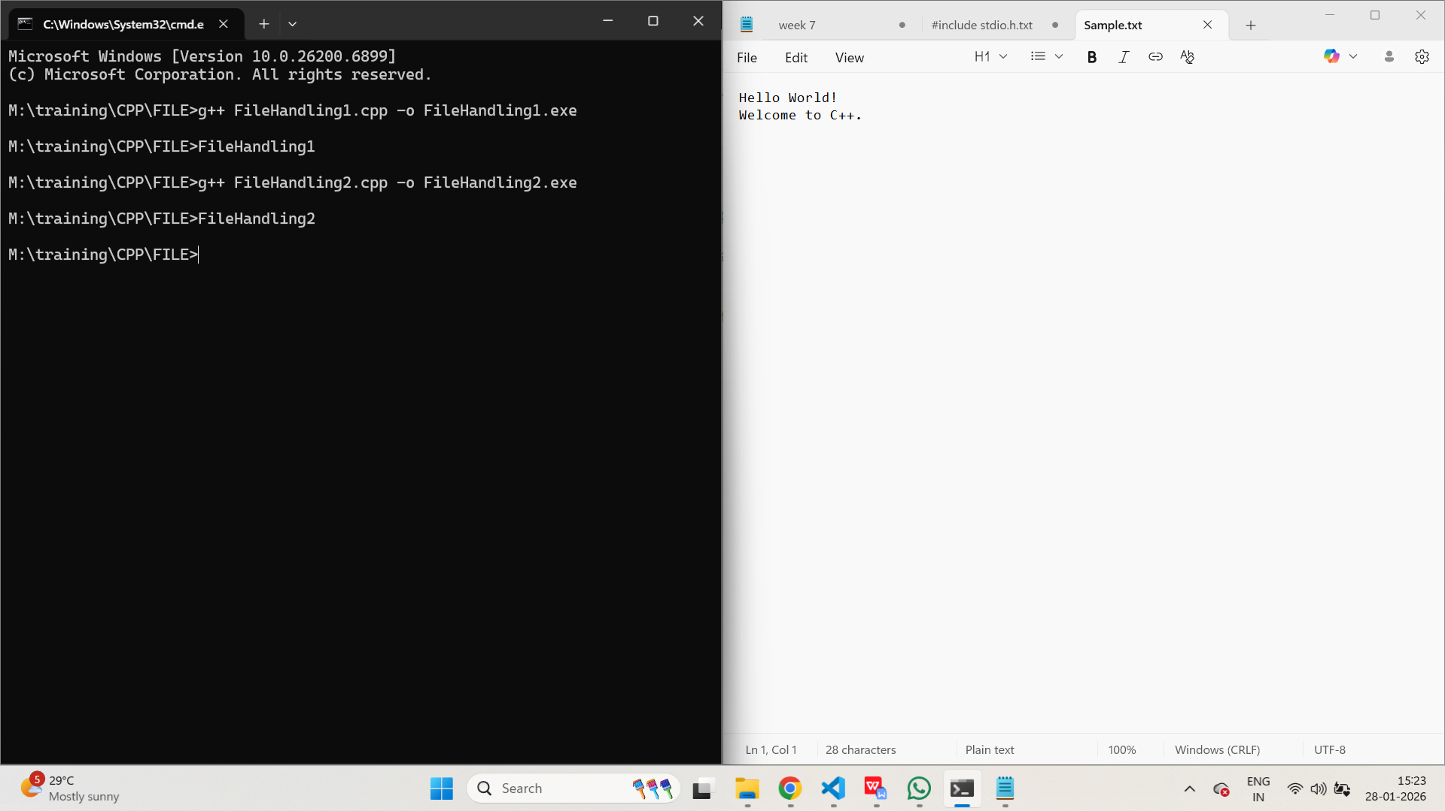

PROGRAM:

/*
* Program to demonstrate virtual functions in C++
* 3. open and read text from the file
* Author : MUTHUGANESH S
* Date : 28/1/2026
* Filename: FileHandling3.cpp
* retval : void
*/

#include <iostream>
#include <fstream>
using namespace std;

int main(){
fstream File;
string Text;

File.open("Sample.txt", ios::in); // Open file in read mode
if(!File){
cout << "Error in opening file for reading..." << endl;
return -1;
}
while(getline(File, Text)){
cout << Text << endl;
}
File.close(); // Close file
}

OUTPUT:

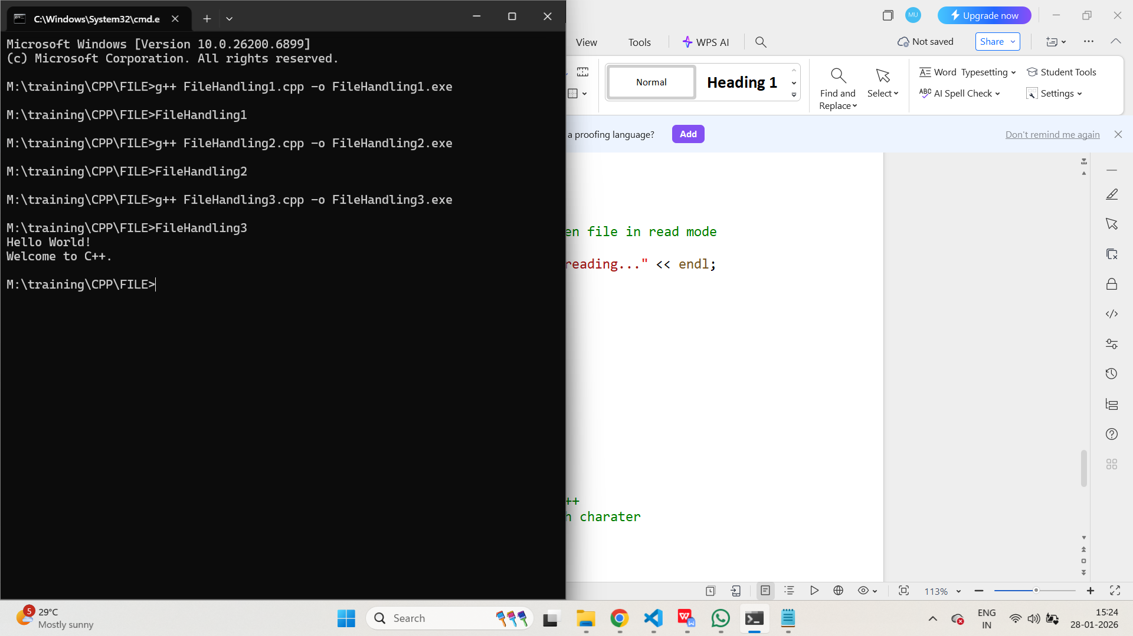

PROGRAM:

/*
* Program to demostrate file handling in C++
* 4. open file and print content after 20th charater
* Author : MUTHUGANESH S
* Date : 28/1/2026
* Filename: FileHandling4.cpp
* retval : void
*/

#include <iostream>
#include <fstream>
using namespace std;

int main(){
fstream File;
string Text;

File.open("Sample.txt", ios::in); // Open file in read mode
if(!File){
cout << "Error in opening file for reading..." << endl;
return -1;
}
File.seekg(20, ios::beg); // Move pointer to 20th character
while(getline(File, Text)){
cout << Text << endl;
}
File.close(); // Close file
}

OUTPUT:

